# CHAPTER 1

1. **Database Objects**

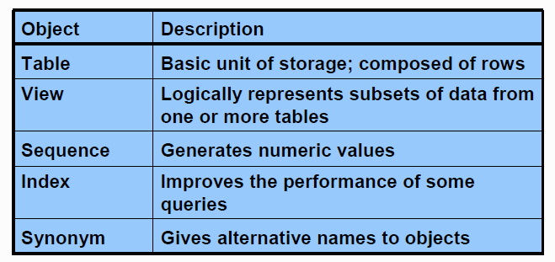

1. **SQL statements**

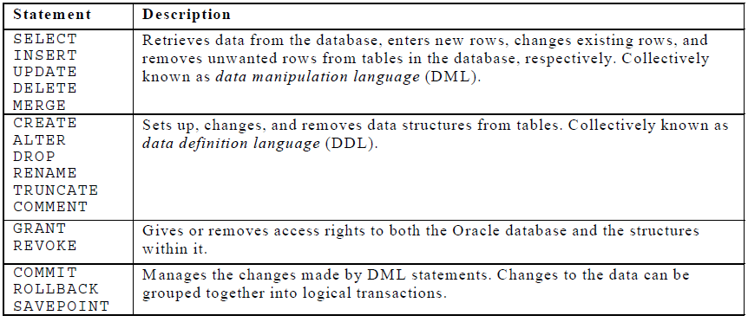

**COMMIT**       :    Make changes done in  transaction permanent.

*Example*

*insert into emp (empno,ename,sal) values (101,’Abid’,2300);*

*commit;***ROLLBACK**:    Rollbacks the state of database to the last commit point.

To rollback the changes done in a transaction give rollback statement. Rollback restore the state of the database to the last commit point.

*Example :*

*delete from emp;*

*rollback;          /* undo the changes */*

**SAVEPOINT**:    Use to specify a point in transaction to which later you can rollback.

Specify a point in a transaction to which later you can roll back.

*Example*

*insert into emp (empno,ename,sal) values (109,’Sami’,3000);  
savepoint a;  
insert into dept values (10,’Sales’,’Hyd’);  
savepoint b;  
insert into salgrade values (‘III’,9000,12000);*

Now if you give

rollback to a;

Then  row from salgrade table and dept will be roll backed. At this point you can commit the row inserted into emp table or rollback the transaction.

If you give

rollback to b;

Then row inserted into salgrade table will be roll backed. At this point you can commit the row inserted into dept table and emp table or rollback to savepoint a or completely roll backed the transaction.

If you give

rollback;

Then the whole transactions is roll backed.

If you give

commit;

Then the whole transaction is committed and all savepoints are removed.

1. **Connect to database**

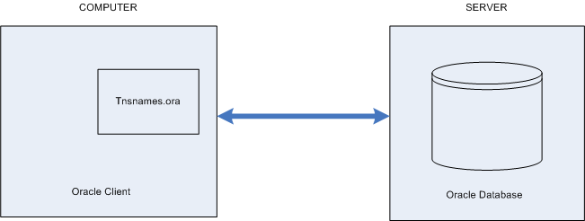

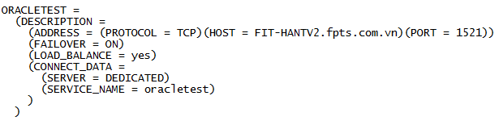

1. **SQL Navigator**

* Log in

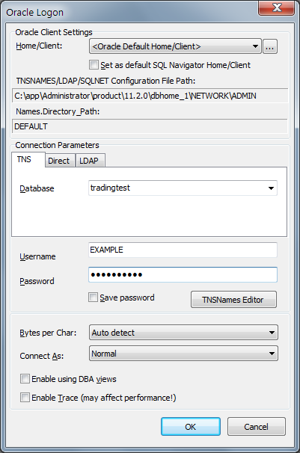

* Open file

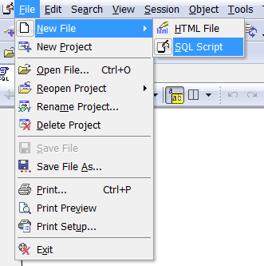

* Tool Bar

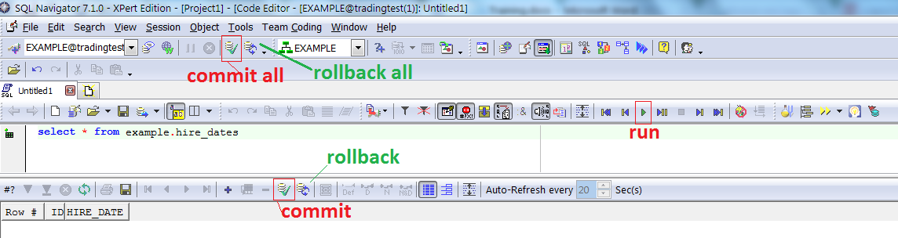

1. **Table in course**

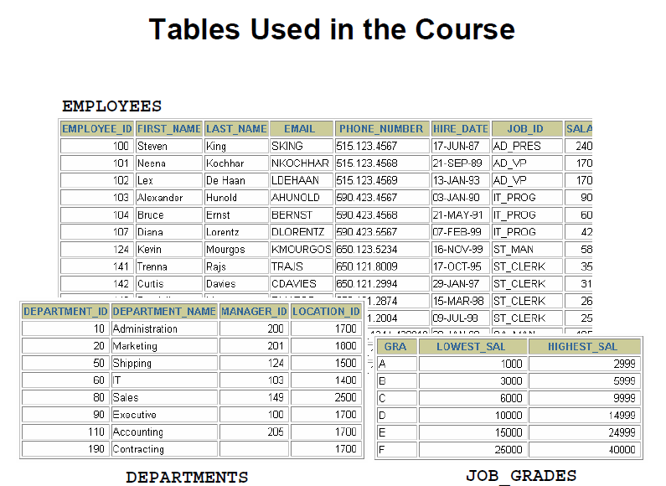

The following main tables are used in this course:

* EMPLOYEES table: Gives details of all the employees
* DEPARTMENTS table: Gives details of all the departments
* JOB_GRADES table: Gives details of salaries for various grades

1. **Templates**

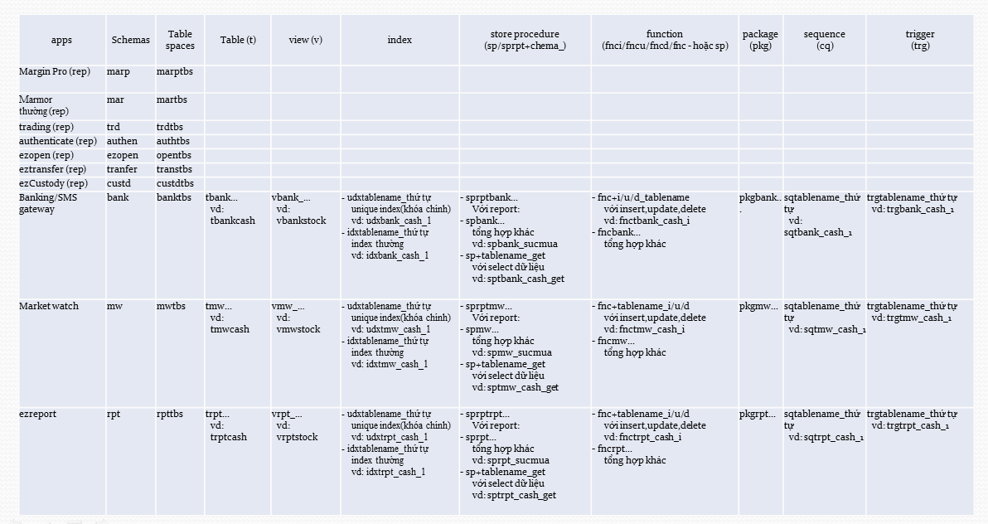

### **Name**

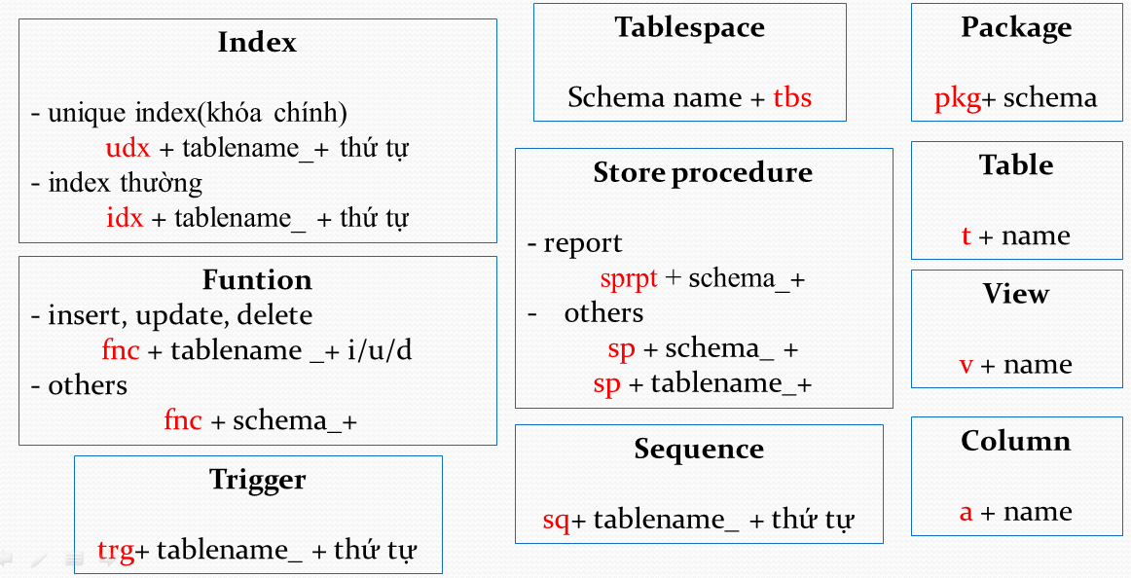

### **Statements**

#### Insert

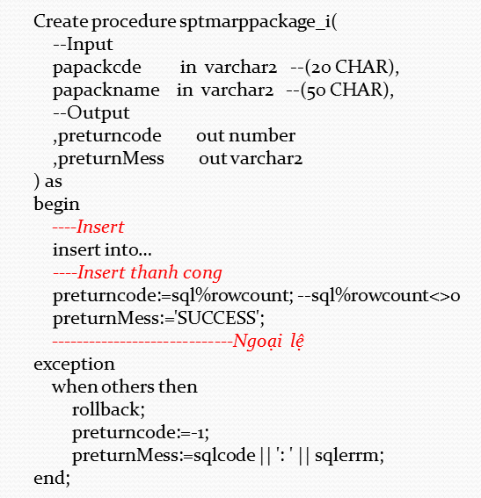

#### Insert nhiều row vào bảng – sử dụng DUAL

DUAL là 1 bảng được tạo tự động bởi Oracle Database như 1 từ điển dữ liệu.

Mọi người dùng trong hệ thống đều có quyền truy cập bảng DUAL.

Nó chỉ có 1 cột DUMMY kiểu VACHAR2(1) và gồm 1 dòng có giá trị X.

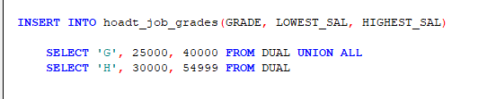

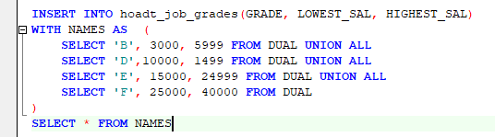

#### Insert toàn bộ dữ liệu bảng A vào bảng B cùng cấu trúc

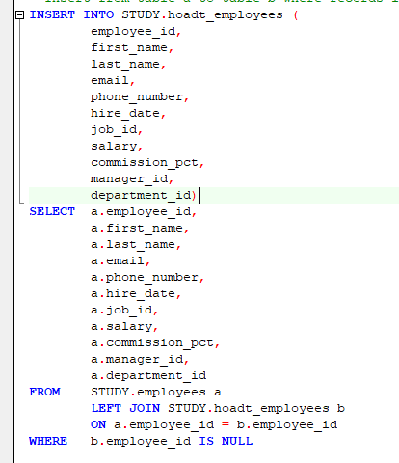

#### Update

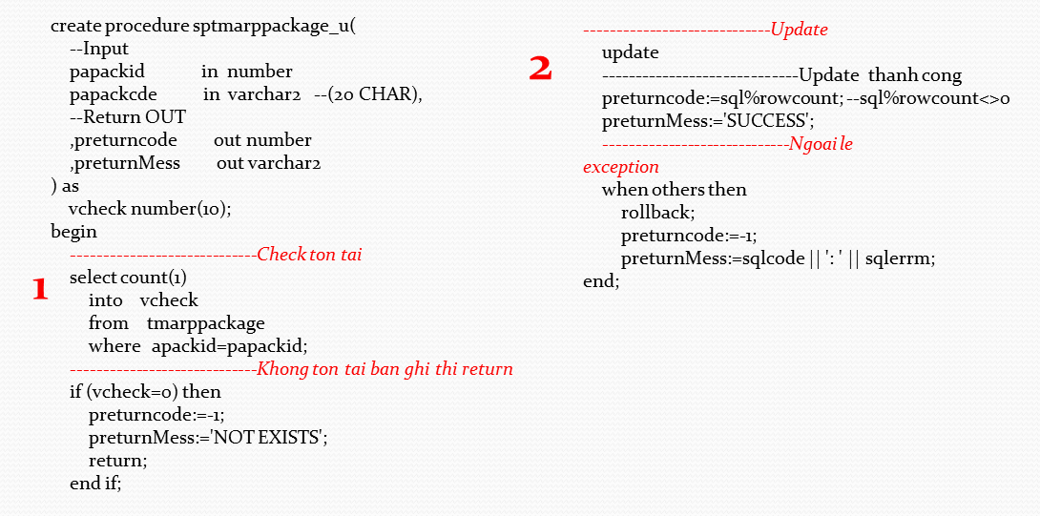

#### Delete

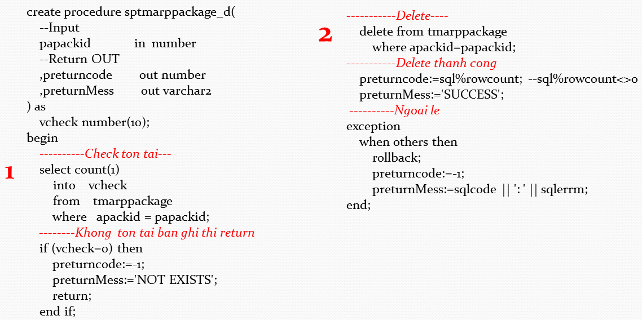

#### Insert & Update

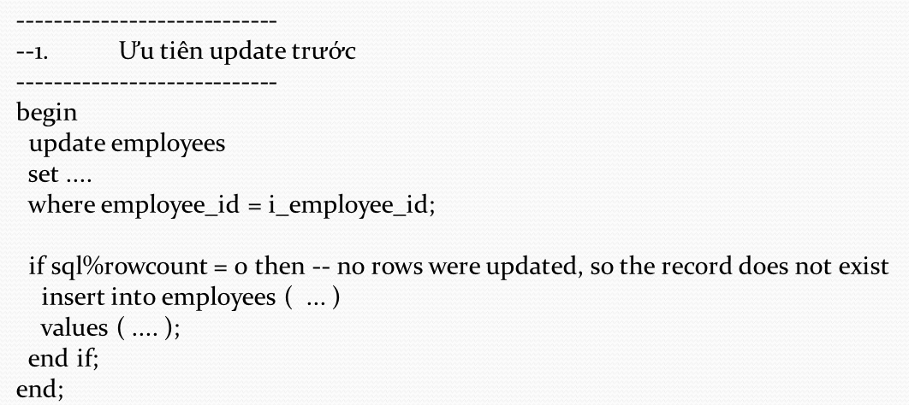

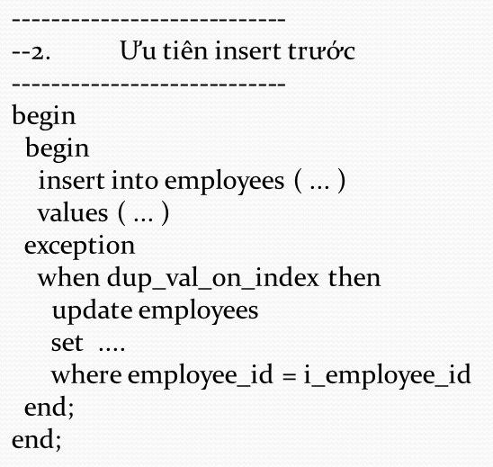

# CHAPTER 2

1. **Dual table**

DUAL is a dummy table that you can use to view results from functions and calculations.

1. **Data types**

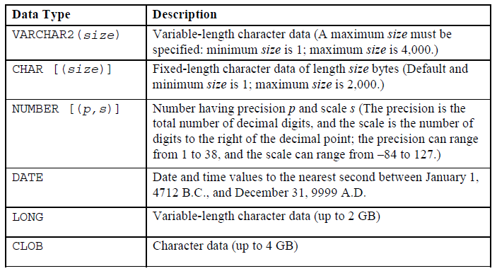

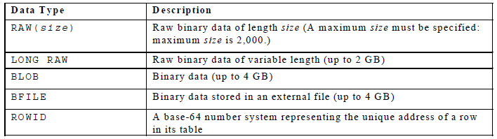

**Guidelines**

A LONG column is not copied when a table is created using a subquery.

A LONG column cannot be included in a GROUP BY or an ORDER BY clause.

Only one LONG column can be used per table.

No constraints can be defined on a LONG column.

You might want to use a CLOB column rather than a LONG column.

1. **Create / Alter table**

* Create:

Syntax:

**CREATE TABLE [*schema*.]*table***

**(*column datatype* [DEFAULT *expr*][, ...]);**

*schema* is the same as the owner’s name

*table* is the name of the table

DEFAULT *expr* specifies a default value if a value is omitted in the INSERT

statement

*column* is the name of the column

*datatype* is the column’s data type and length

Example:

**CREATE** **TABLE** job_grades

(grade **CHAR**(1 **BYTE**) ,

lowest_sal **NUMBER**(8,2) **NOT** **NULL**,

highest_sal **NUMBER**(8,2) **NOT** **NULL**

)

Create table with sub-query

**CREATE TABLE [*schema*.]*table***

**AS**

**SELECT ……;**

Example:

**create** **table** example.hire_dates_bk

**as**

**select** * **from** example.hire_dates

* Alter
  + Add a new column
  + Modify an existing column
  + Define a default value for the new column
  + Drop a column

Syntax:

alter table  
   table_name  
add  
   (  
   column1_name column1_datatype column1_constraint,    
   column2_name column2_datatype column2_constraint,  
   column3_name column3_datatype column3_constraint  
   );

Example:

alter table   
   author   
add   
   (author_last_published date,  
    author_item_published varchar2(40));

* Drop table

The DROP TABLE statement removes the definition of an Oracle table. When you drop a table, the database loses all the data in the table and all the indexes associated with it.

**Syntax**

DROP TABLE *table*

In the syntax, *table* is the name of the table.

* Confirm

Syntax:

Describe table

Example

describe job_grades

1. **Constraints**

Constraints enforce rules at the table level.

Constraints prevent the deletion of a table if there are dependencies.

The following constraint types are valid:

* NOT NULL
* UNIQUE
* PRIMARY KEY
* FOREIGN KEY
* CHECK

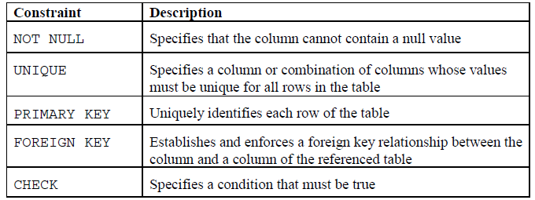

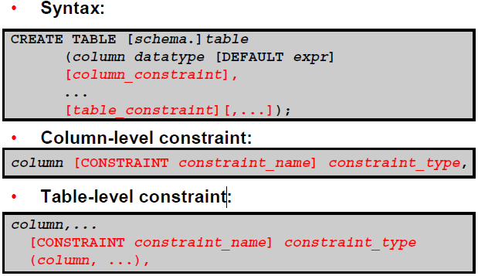

In the syntax:

schema is the same as the owner’s name

table is the name of the table

DEFAULT expr specifies a default value to use if a value is omitted in the

INSERT statement

column is the name of the column

datatype is the column’s data type and length

column_constraint is an integrity constraint as part of the column definition

table_constraint is an integrity constraint as part of the table definition

Example

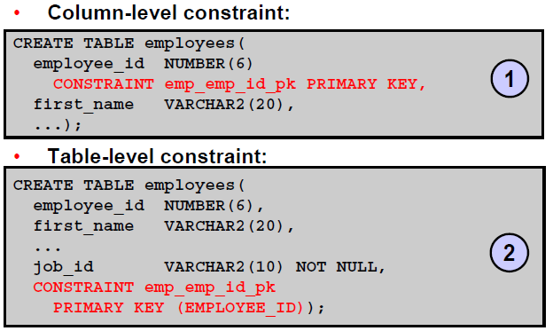

1. **Referencing Another User’s Tables**

* Tables belonging to other users are not in the user’s schema.
* You should use the owner’s name as a prefix to those tables.

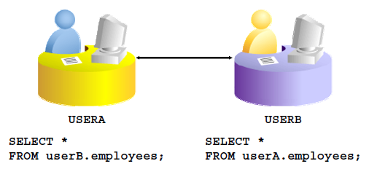

1. **Practice**
   1. Create the Employee, Department, Job_Grades table based on the following table and confirm table is created

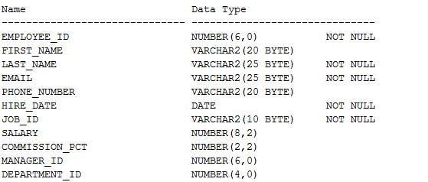

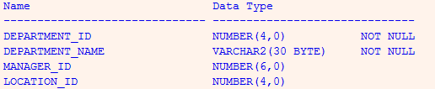

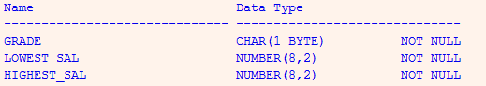

* 1. Create table Dept table based on the following table and confirm table is created

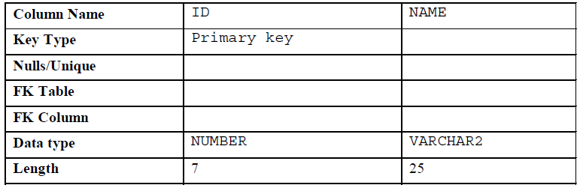

* 1. Create table Emp table based on the following table and confirm table is created.

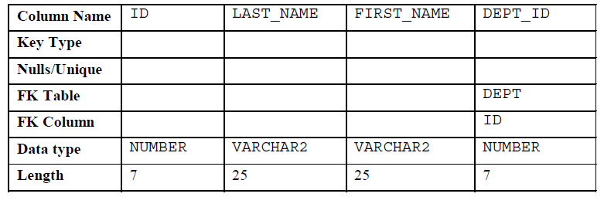

* 1. Alter table Emp table add “Email” column. Confirm table is altered
  2. Create table Emp2 table based on the structure of the Employees table. Include only the EMPLOYEE_ID, FIRST_NAME, LAST_NAME, SALARY, and DEPARTMENT_ID columns. Name the columns in your new table ID, FIRST_NAME, LAST_NAME, SALARY , and DEPT_ID
  3. Drop the Emp table.